Matthew

Observations and Playtester Comments

# In-Game Observations

[Your thoughts as you watch the testers play]

* Still need to add empathy value system
* Need to add a way to win still too

# In-Game Questions

Why did you make that choice? (why didn’t you look in the middle of the game?)

* Just went around perimeter and didn’t pay attention to stuff in the middle

What did you think that would do? (what did you think interacting with people would do)

* Give me more stats

What is confusing for you?

* How do I win?

# Postgame Questions

[Questions you ask the testers as they have played]

* Was it still fun without being able to win?
  + Yes, this is a type of game I would play
* What games would you compare it to?
  + Pokemon or stardew valley

## General Questions

What was your ﬁrst impression?

* impressive

How did that impression change as you played?

* No change

Was there anything you found frustrating?

* Not really

Did the game drag at any point?

* Too much reading

Were there particular aspects that you found satisfying?

* Good story, interesting setting

What was the most exciting moment in the game?

* When I entered the castle

Did the game feel too long, too short, or just about right?

* Never ends, so need an ending

## Formal Elements

Describe the objective of the game.

* Walk around and talk to people

Was the objective clear at all times?

* yes

What types of choices did you make during the game?

* Walk around the perimeter, and ignore the middle

What was the most important decision you made?

* To leave the first house

What was your strategy for winning?

* NA

Did you ﬁnd any loopholes in the system?

* no

How would you describe the conﬂict?

* I want to win but cannot win

In what way did you interact with other players?

* NA

Do you prefer to play alone or with human opponents?

* Other people

What elements do you think could be improved?

* Multiple levels

## Dramatic Elements

Was the game’s premise appealing to you?

* sure

Did the story enhance or detract from the game?

* Kind of verbose, maybe simplify it

As you played, did the story evolve with the game?

* Got the whole story before began the game

Is this game appropriate for the target audience?

* sure

On a piece of paper, graph your emotional involvement over the course of the game.

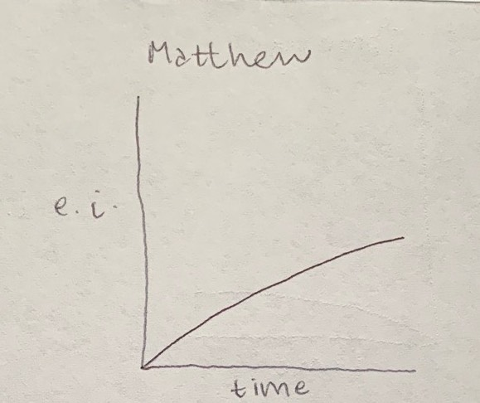

Did you feel a sense of dramatic climax as the game progressed?

* Not really

How would you make the story and game work better as a whole?

* Less text, more action

## Procedures, rules, interface, and controls

Were the procedures and rules easy to understand?

* yes

How did the controls feel? Did they make sense?

* Felt fine, made sense

Could you ﬁnd the information you needed on the interface?

* yes

Was there anything about the interface you would change?

* No

Did anything feel clunky, awkward, or confusing?

* no

Are there any controls or interface features you would like to see added?

* no

## End of Session

Overall, how would you describe this game’s appeal?

* Interesting storyline, interesting setting

Would you purchase this game?

* Maybe for $1

What was missing from the game?

* Multiple levels, combat system, point system implementation

If you could change just one thing, what would it be?

* Add a working point system

Who do you think is the target audience for this game?

* nerds

If you were to give this game as a gift, who would you give it to?

* Little brother

# Revision Ideas

[Ideas you have for improving the game]

* In the long run, pick up and drop items
* Maybe add combat system